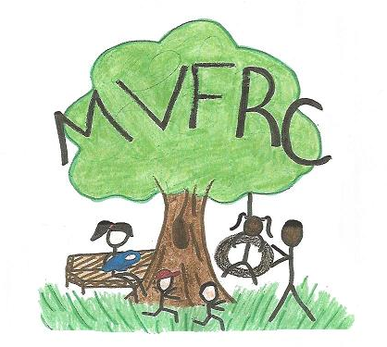Musquodoboit Valley Family Resource Centre

How To Talk So Kids Will Listen
&
Listen So Kids Will Talk

A parent education program focusing on social – emotional well being and discipline within a family atmosphere of love and respect.

Wednesdays 10:00 – 11:30 am
6 sessions - Feb. 1 to March 8, 2023

Please call 902-568-0042 to register.

