M.V.E.C. Curriculum Night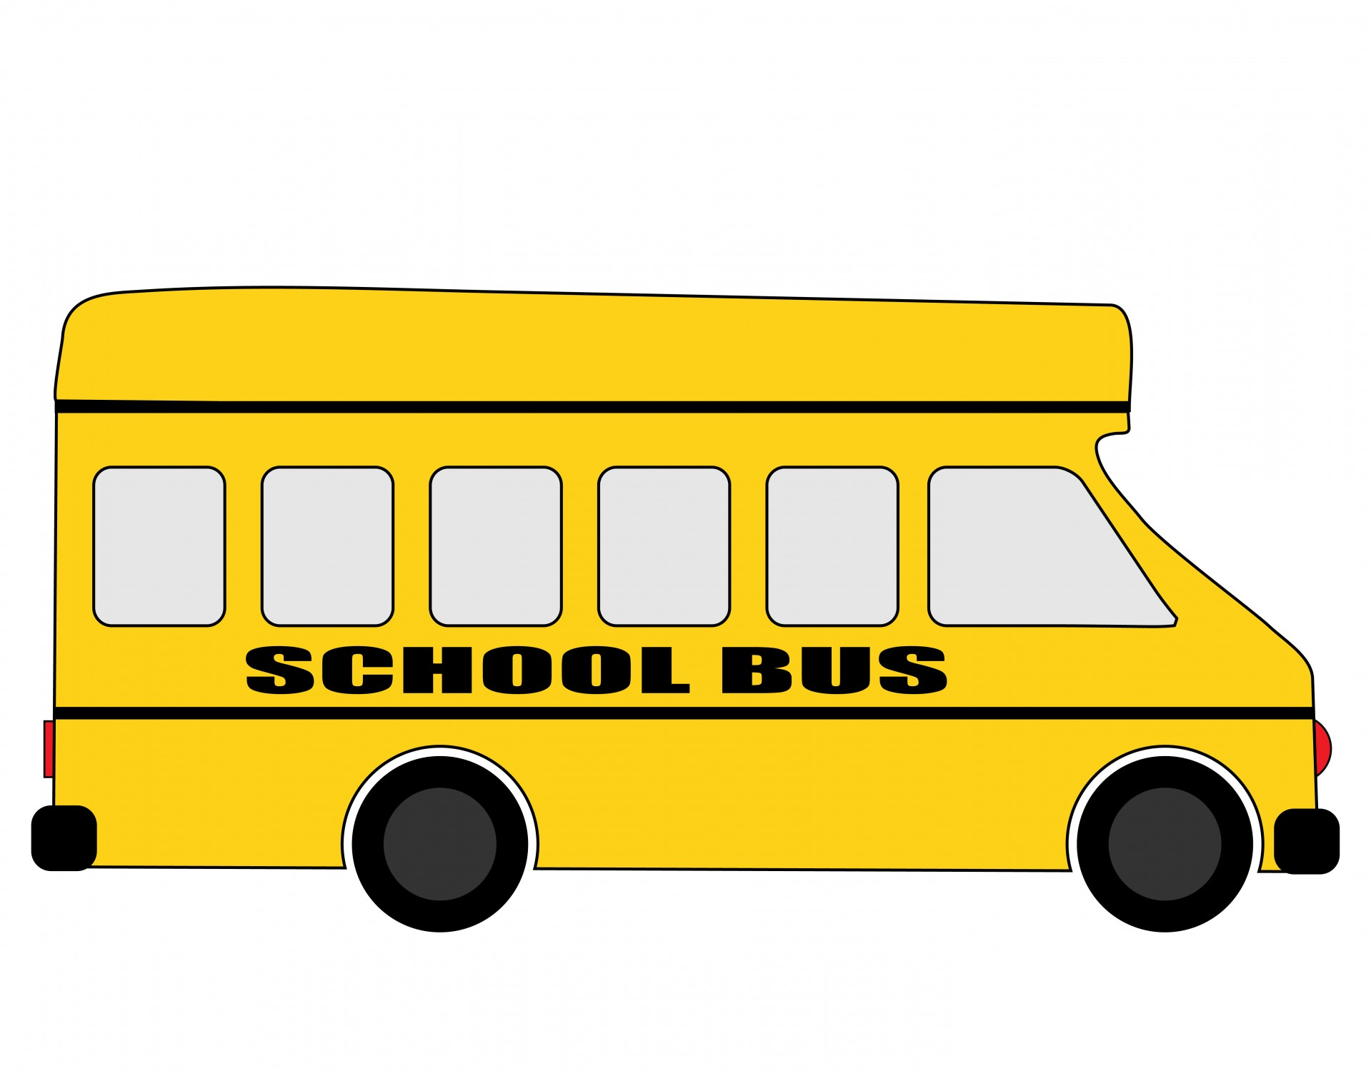
2021 - 2022

Welcome to another school year here at M.V.E.C! I am absolutely thrilled to be your child’s teacher, and very excited about the 2021 - 2022 school year. Learning should be fun, engaging, teach independence and personal responsibility. I will do my best to promote and accommodate this style of learning. Please don’t ever hesitate to contact me at: tony.odo@gnspes.ca (preferred) or 250-210-9397.

Please see the reverse side of this handout for an overview of your child’s curriculum for the school year. Below is a breakdown of how the Math and English Language Arts program will run in our classroom. Please note, that for all the ways that your child will learn this year, proper sanitation, mask-wearing and social distancing measures will be put in place, in accordance with Public Health guidelines for public schools.

Math: Students will be involved in daily mental math activities focusing on patterns in numbers, strategies for adding and subtracting mentally, and communicating these strategies with peers. Math outcomes will be met through a daily math workshop, where students are given the opportunity to use manipulatives to explore math related concepts with a hands-on approach to learning. Students will be given opportunities to work independently and share aloud with peers to solve math problems based on their grade level outcomes.

English Language Arts: consists of reading, writing, and speaking & listening. Through writer’s and reader’s workshops, students will be engaged in meaningful discussions that will guide them to become more proficient in their reading and writing. With Nova Scotia’s integrated curriculum, students will apply literacy learning to all the other subject areas, like science, social studies, health and visual arts.

Assessment Practices include, but are not limited to, observational notes, conversations/discussions, think-pair-shares, student self-assessment, quizzes/tests, student work samples and projects. A variety of these practices will be utilized to assess student's learning.

Grade 3 Curriculum

 | Math | English Language Arts | Science | Social Studies | Health | Visual Art
Term 1 | Numbers to 1000.  Patterning with geometry and time.  Place Value to 1000. | Communicate effectively and clearly and respond personally and critically.  Select, interpret, and combine information. | Structures | Exploring Nova Scotia within the Atlantic region. | Communicate ways to manage difficulties in friendships. | Explore and manipulate a range of materials and processes to create artworks.
Term 2 | Statistics  Add. & sub. Of 3 digit numbers to 1000.  Geometry & measurement (mass).  Add. & sub. Of 3 digit numbers to 1000. | Create texts using a variety of forms.  Interact with sensitivity and respect, considering audience and purpose. | Magnets | Take actions to promote positive interactions among people. | Learn ways to ask for help in unsafe risk scenarios. | Examine a broad range of artworks from different cultural backgrounds.
Term 3 | Fractions of a whole  Add. & Sub. and extending place value to 1000.  Measurement (length & perimeter)  Mulit. & Division.  Add. & Sub. and patterns & relations. | Use a range of strategies to develop effective writing and media products to enhance their clarity, precision and effectiveness. | Exploring soils and growth and change in plants | Examine the rights and responsibilities of citizens in a democracy. | Recognize, discuss, and identify decisions that affect physical, social, mental, and emotional health. | Demonstrate an awareness of, reflect upon, and develop respect for art and art-making

