M.V.E.C. Curriculum Night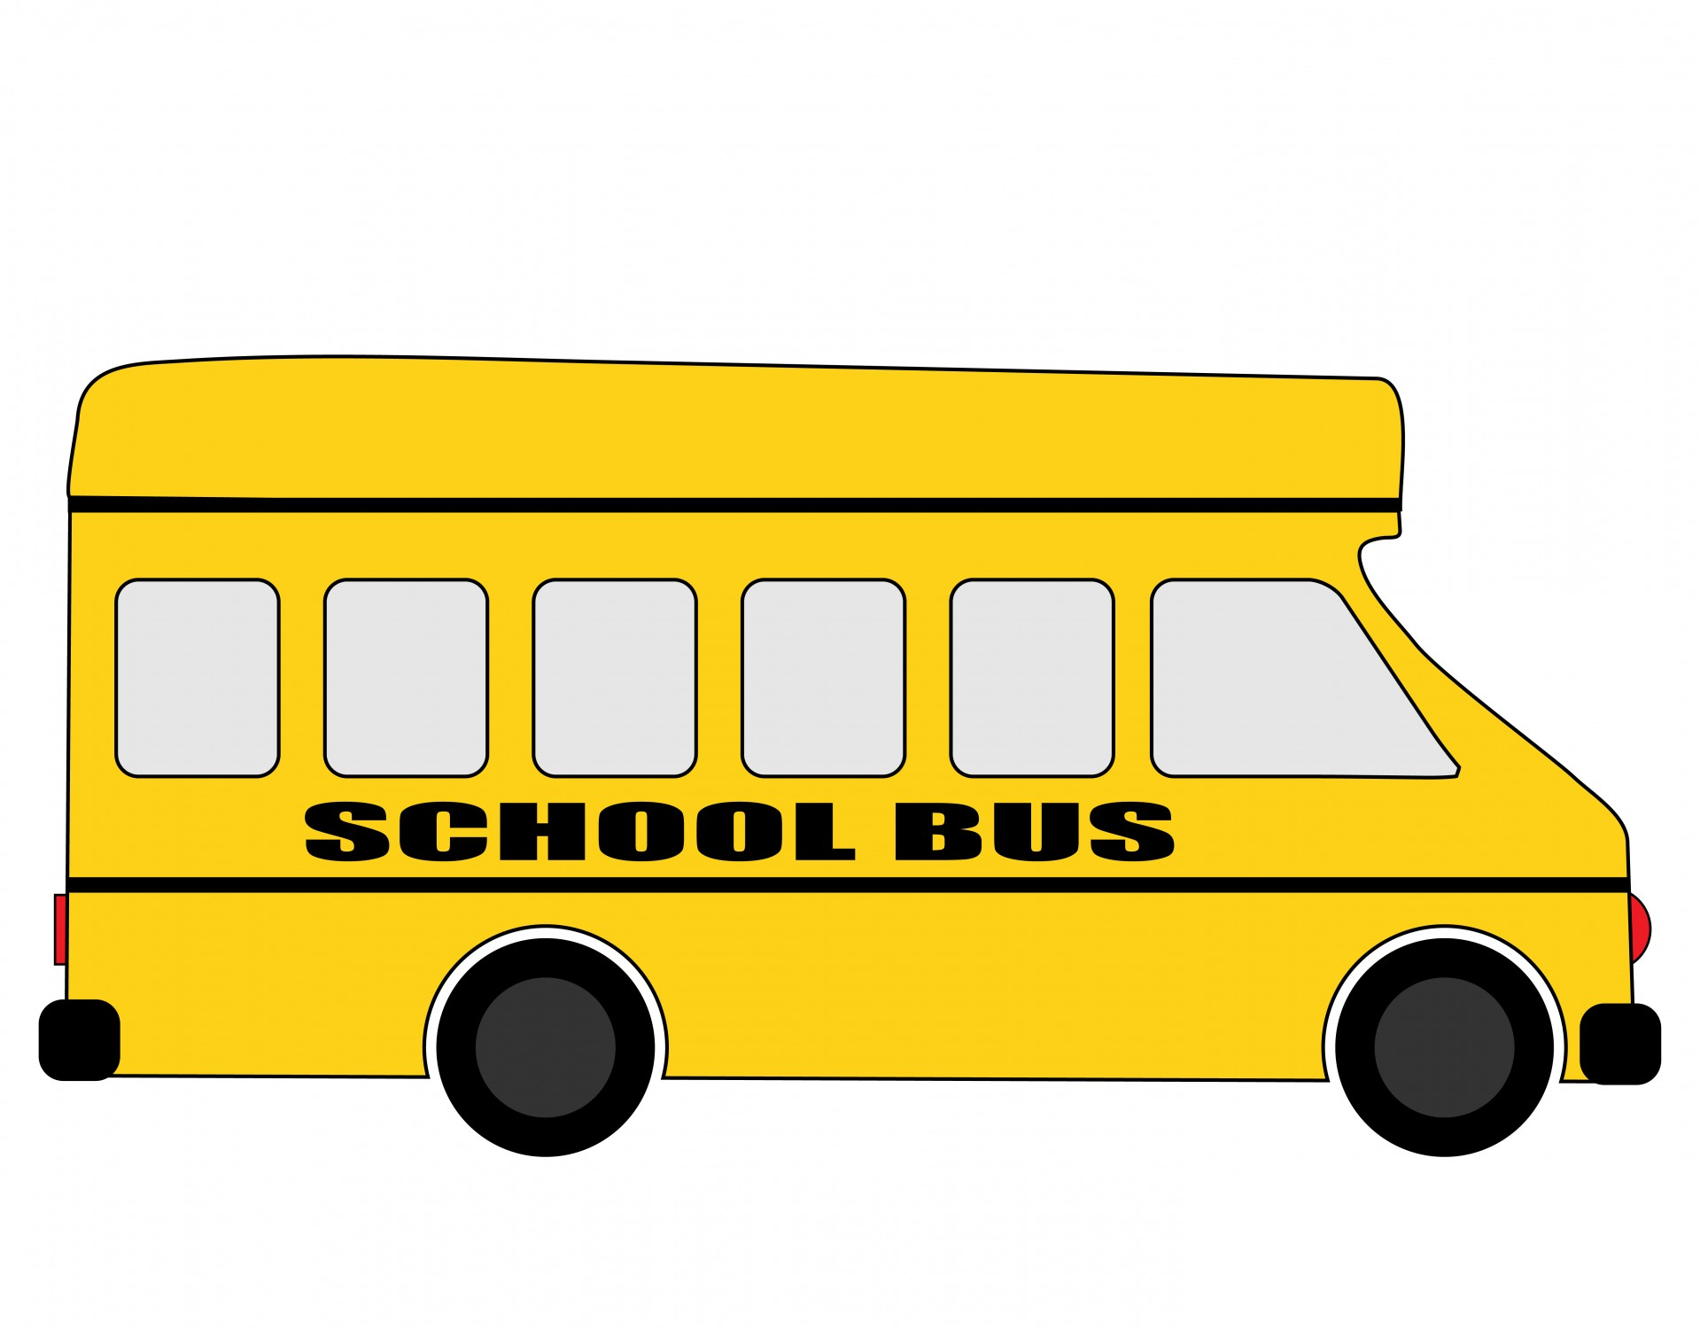
2021 - 2022

Welcome to another school year here at M.V.E.C! I am absolutely thrilled to be your child’s teacher for the 2021 - 2022 school year. I truly believe that it “takes a village” to raise a child, therefore, please don’t ever hesitate to contact me! chughes@hrce.ca or chughes@gnspes.ca 902-384-2555

Math Students will be involved in daily mental math activities focusing on patterns in numbers, strategies for adding and subtracting mentally, and communicating these strategies with peers. Math outcomes will be met through a daily math workshop, where students are given the opportunity to use manipulatives to explore math related concepts with a hands-on approach to learning. Students will be given opportunities to work independently and share aloud with peers to solve math problems based on their grade level outcomes.

English Language Arts consists of reading, writing, and speaking & listening. Through writer’s and reader’s workshops, students will be engaged in meaningful discussions that will guide them to become more proficient in their reading and writing. With Nova Scotia’s integrated curriculum, students will apply literacy learning to all the other subjects areas, like science, social studies, health and visual arts.

Assessment Practices include, but are not limited to, observational notes, conversations/discussions, think-pair-shares, student self-assessment, quizzes/tests, student work samples and projects. A variety of these practices will be utilized to assess student's learning.

Homework Practices The homework program for students will begin the first week of October. Students will be asked to practice their reading strategies from home, either by reading independently or enjoying a read aloud with a friend or family member. As the year progresses, homework may include other activities where students can practice skills learned. Homework or other information from the school can be found in your child’s home communication binder/scribbler.

Grade 2 Curriculum

 | Math | English Language Arts | Science | Social Studies | Health | Visual Art
Term 1 | Numbers to 100  Patterning with Geometry and Time  Place Value: Tens and Ones  Statistics | Interact using effective oral language skills.  Demonstrate ways to comprehend and select from a range of texts.  Select, interpret, and combine information. | Relative Position and Motion | Investigate change in the community. | Investigate the health benefits of active leisure and quiet leisure in having a healthy mind and healthy body. | Explore and manipulate a range of materials and processes to create artworks.
Term 2 | Add. & Sub. and extending number sense (1-digit)  Patterning and Geometry  Add. & Sub. and extending number sense (1 and 2-digit)  Measurement - Mass | Respond personally and critically to a range of texts.  Convey meaning by creating print/digital texts.  Use writing and other forms of representation to express ideas. | Liquids and Solids  Air and Water in the Environment | Investigate how individuals and diverse cultural groups of Nova Scotia have contributed to change. | Investigate empathy | Examine a broad range of artworks from different cultural backgrounds.
Term 3 | Measurement - Length, Height, & Distance Around  Add. & Sub. (Application of Partitioning)  Geometry  Add. & Sub. and Flexibility with Numbers to 100. | Create text, including digital;collaboratively and independently, for a range of audiences and purposes.  Use a range of strategies to develop effective writing. | Animal Growth and Changes | Investigate decisions that are made by consumers.  Analyse ways for supporting sustainable development in local communities. | Investigate ways to be safe at school and in the community. | Demonstrate an awareness of, reflect upon, and develop respect for art and art-making

