Dear Families:
As a support to you at home, especially in the event of a return to learning-at-home, please see below an outline of steps you may take to help your child access the Google applications (GNSPES, aka GAFE), a platform most students use in school and may be required to use if we return to at-home learning. Please retain this information for your records, find it posted to our website under the ‘For Parents’ menu for future reference and do not hesitate to forward questions to an member of your MVEC Family at any time if we can be of further assistance. Your MVEC Family
Instructions for Accessing GNSPES on Home Computers
- Go to our school web page: https://muc.hrce.ca/our-school
- Go to ‘For Students’, and select GNSPES
- Sign in using your Child’s login information. This will take you to the “Google Apps for Education” Launch Page

From here:
Instructions for Accessing Google Classroom
- Under the heading Classroom, you will see a green Icon titled “Classroom.
Once you’ve clicked on this you will see all of the “Classrooms” that your child is enrolled in
- There are classrooms for most subject areas. All new and old assignments will be found here. Students will also be notified via gmail when new assignments are posted in their classrooms
Instructions for Accessing Gmail
- Under the heading Backpack, you will see an app titled “Gmail”.
Simply click that icon to access your child’s gmail account. This will important for your child to join online meetings with their teachers
Instructions for Accessing 'Google Meet’
- IMPORTANT! When joining a “Google Meet” the invitation will be sent in Gmail AND will appear in your child’s calendar. To join the meeting, students will need to click the invitation in their mail, OR the event in their calendar, to join. PLEASE DO NOT CLICK “GOOGLE MEETS” TO ATTEMPT TO JOIN A MEETING
*Meets” is an application that allows students to meet with their teacher in groups or one-on-one. All Chromebooks and Tablets are equipped with microphones and cameras. You may want to check and see if your home devices are also equipped.

Instructions for Accessing Docs
- Under the heading Backpack, you will see an app titled “Drive”. 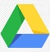 Simply click that icon to access your child’s Drive
- Near the top right corner of the screen, you will see an icon with nine dots called the ‘waffle’ (because it looks like a waffle). Clicking this will give you quick access to many of the Google apps
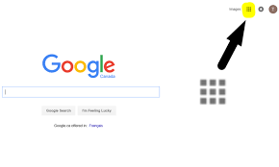
Click on “Docs”. To begin a new doc, click on the + icon and begin working

*Drive is a place where ALL of your child’s work is automatically stored. Think of it as an online hard drive or jump drive
*Docs is a word processing app similar and compatible to Microsoft word. Saving is done automatically every three seconds. Multiple students can type on the same doc, if shared with other people. PLEASE ENCOURAGE YOUR CHILD TO GIVE A TITLE TO EACH DOCUMENT SO THEY DON’T HAVE MANY ‘UNTITLED DOCS’ TO SEARCH THROUGH
*The Waffle is a hub where commonly used apps will appear. To return to a screen to access the waffle, click the Docs button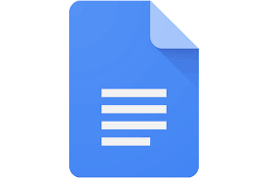 on the left side of the screen
Instructions for How to Make a Doc YOUR OWN- A VERY important step
Your child’s teachers will be assigning work to be completed on a specific Doc. It must be copied and stored in your child’s Drive before they type on it, otherwise the whole class will type on the same doc and students will be unable to submit their work.

- Open the assigned Doc in the classroom assignment
- Click on “File” in the task bar in the top left corner of the Doc
- Select “make a copy”
- Rename the doc. Use the name of the file and add your name, so that your teacher will know who it is from
- Share with your teacher, by clicking the blue share button near the top right corner of the screen
- Close the original Doc
- Select your newly created copy and share it with your teacher
- Begin working

