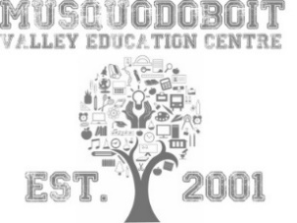
Musquodoboit Valley Education Center

ABOUT MY CHILD- PRIMARY ORIENTATION

CHILD’S FULL NAME: ___________________________________________

Has your child been in Pre-School/Pre-Primary? ______ Yes ______ No

Since you are your child’s first and most important teacher, we would like to know from you what information you feel would help us to understand and support your child in their first year of school. Please write about your child. You can make a list, make jot notes, write a letter or use any form of writing that you wish. Let us know things like his/her likes, dislikes, special needs, favourite books, fears, talents, abilities as you see them, areas of interest, health concerns, physical needs, etc.

____________________________________________________________________________________________________________________________________________________________________________________________________________________________________________________________________________________________________________________________________________________________________________________________________________________________________________________________________________________________________________________________________________________________________________________________________________________________________________________________________________________________________________________________________________________________________________________________________________________________________________________________________________________________________________________________________________________________

_________________________ ____________________________________
DATE SIGNATURE OF PARENT

